We made it through our first week of Virtual Learning! I want to thank you for all your patience and understanding this week as we work through things together.

Each week you will be receiving a newsletter from me. It will contain an overview of the skills the students will be working on for the upcoming week. It will also have the link to the upcoming week’s learning packets as well as important reminders or notices. Please be on the lookout for this each Friday afternoon.

Academic Content for this Upcoming Week:

ELA/Reading
- Rhyming Words
- Alliteration
- Character analysis
- Role of the author
- Writing about yourself

Math
- 2D and 3D shape identification
- Counting to 20
- Sorting 2D and 3D shapes and describing their differences
- Understanding that shapes remain the same regardless of their size or orientation

Science/SS
- Maps and globes
- Sink/float
- Practicing your own address

Gentle Reminders:
- Please remember to mute your mic as soon as you are done talking
- Please remember to click the hand raised button again to lower your hand
**We appreciate your help with this!! 😊

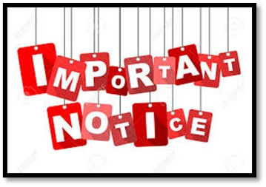
Learning Packets:
This was sent out in the Bobcat letter and in an email blast, but please see the link below (if you haven’t already) regarding new information about the learning packets.

SBCE PK - 2 Learning Bundle Flyer

Additionally, here is the link for this upcoming week’s learning packet. Our CST has reorganized the packet, so it is much easier to understand which sheets are for which day. We are super excited about this!

Kindergarten

Please look for an additional attachment regarding the iReady diagnostic test. Students should not be logging into iReady prior to taking the test. More information to come.

As always, please feel free to reach out to me with any questions or concerns. Great job on the first week, students AND parents!!

Thank you for all you do!

Gratefully,

Ms. Brewington and Ms. Joyce

